Building Regulation Application
Gloucestershire Building Control Group

 | THE BUILDING ACT 1984  THE BUILDING SAFETY ACT 2022  THE BUILDING REGULATIONS 2010 | 

Please read the notes on the reverse side of this form or consult the office indicated on page 3

 |  | PLEASE TYPE OR USE BLOCK CAPITALS
1 |  |  | Submission details (tick as appropriate)
 |  |  | Building Notice |  |  |  |  |  |  | Resubmission |  |  |  |  |  |  |  | For Resubmission, please give previous reference number:
2 |  |  | Address where building work is to be carried out
 |  |  | Address:
 |  |  |  |  |  |  |  |  |  |  |  |  |  |  |  |  | Postcode:
 |  |  | Note: A location plan sufficient to readily identify the site should be included
3 |  |  | Full description of the work (e.g. single storey extension to enlarge the lounge)
 |  |  | Commencement date if known: |  |  |  |  |  |  |  |  |  |  |  |  |  | No of storeys:
4 |  |  | Applicant’s details (please give FULL name, postal address and contact details)
 |  |  | Name:
 |  |  | Address:
 |  |  | Postcode: |  |  |  |  |  |  |  |  |  |  | Tel/Mob
 |  |  | Email:
5 |  |  | Agent’s details (if applicable, please give details of the person dealing with the project e.g architect, surveyor)
 |  |  | Company: |  |  |  |  |  |  |  |  |  | Contact Name:
 |  |  | Address:
 |  |  | Postcode: |  |  |  |  |  |  |  |  | Tel/Mob
 |  |  | Email:
6 |  |  | Person who has liability for payment of Inspection Charge
 |  |  | Name:
 |  |  | Address:
 |  |  |  |  |  |  |  |  |  |  |  |  |  |  |  |  | Postcode:
 |  |  | (If a NON LTD company is liable for payment, please provide the proprietors name eg “Mrs D Walker t/as Dots Café”)
7 |  |  | Builders details (If known)
 |  |  | Name:
 |  |  | Tel: |  |  |  |  |  | Email:

8 |  | Use of building
 |  | Present use: |  |  |  |  |  |  | Proposed use:
Will the building or part thereof be put to a use which is designated under the Fire Safety Regulatory

Reform Order 2005: (e.g. hotels, boarding houses, factories, offices, shops etc) YES NO

Please note that an additional set of drawings is required to enable consultation with the Fire Service
9 |  | Conditions (Full Plans Submissions only)
 |  | Do you consent to the plans being passed subject to conditions where appropriate? YES NO
10 |  | Prescribed Period (Full Plans Submissions only)
 |  | The statutory time period for dealing with your application may, by agreement, be extended from 5 weeks to 2 months if necessary.
 |  | Do you agree to this? YES NO
11 |  | Mode of drainage and water supply (e.g. to an existing mains sewer or to a new treatment plant)
 |  | Foul Water: |  |  |  |  |  |  |  |  | New  Existing  |  |  | (please specify)
 |  | Surface Water: |  |  |  |  |  |  |  |  | New  Existing  |  |  | (please specify)
 |  | Water Supply: |  |  |  | Mains | Other: |  |  |  |  |  |  | (please specify)
12 |  | Commencement of work
 |  | Please provide information as to the date when it is proposed the building work will be commenced in accordance with regulation 46A of the building regulations. For a building with foundations this means when the foundations will have been placed and the construction up to ground floor level is complete. For other building work this will be when 15% of the works are completed.
 |  | Date:
13 |  | Energy Rating
 |  | Required for all new build dwellings, non-domestic new build and non-domestic extensions over 500m²
 |  | Please state method of compliance & enclose of copy of the relevant certification:
14 |  | Domestic electrical installations
 |  | Please ensure that the person carrying out the works is suitably qualified and that they can self certify the work and issue a BS7671 certificate. Please confirm whether your electrician is a member of an approved competent person scheme:
 |  |  | YES |  | Details
 |  |  | NO
 |  |  | For a list of all scheme members go to www.competentperson.co.uk
15 |  | Planning Permission
 |  | Persons proposing to carry out work or make a material change of use of a building are reminded that permission may be required under the Town and Country Planning Acts:
 |  | Have you checked if you require planning or listed building consent for the works? |  |  |  |  |  |  |  |  |  |  | YES NO
 |  | Have you made an application for planning or listed building consent for the works? |  |  |  |  |  |  |  |  |  |  | YES NO
 |  | If yes, what is the application reference number?

 |  | FEES (please see the accompanying fee schedule for the appropriate Council)
16 |  | Disabled works
 |  | Is the work to provide a facility for a registered disabled person? |  |  |  |  |  |  |  |  |  |  |  |  | YES NO
17 |  | TABLE 1 | Erection of new dwellings up to 3 storeys & not more than 300m² in floor area
 |  | Is the development funded: |  | Privately |  |  |  |  | Plot No(s):
 |  |  |  | Housing Association |  |  |  |  | Plot No(s):
 |  |  |  | Local Authority |  |  |  |  | Plot No(s):
 |  |  | Number of Dwellings:
 |  |  |  |  |  |  |  |  |  |  | Fee due: |  |  |  |  | £
 |  |  | Internal floor area: |  |  |  |  |  |  | m²
18 |  | TABLE 2 | Domestic extensions, loft conversions, detached garages/carports
 |  |  | Garage/carport internal floor area: |  |  |  |  |  |  |  | m² |  | Fee due: |  |  |  |  |  | £
 |  |  | Extension internal floor area: |  |  |  |  |  |  |  | m² |  | Fee due: |  |  |  |  |  | £
 |  |  | Loft conversion internal floor area: |  |  |  |  |  |  |  | m² |  | Fee due: |  |  |  |  |  | £
 |  |  | (For floor areas over 100m² please use Table 3)
19 |  | TABLE 3 | Other works based on estimated cost
 |  |  | Estimated cost (excluding vat): |  |  |  |  | £ |  |  | Fee due: |  |  |  |  |  |  | £
 |  |  | (You may be required to provide an estimate)
20 |  | TABLE 3a Miscellaneous Minor Works
 |  |  |  |  |  |  |  |  |  |  | Fee due: |  |  |  |  |  |  | £
21 |  | Statement
 |  | This notice is given in relation to the building work as described, in accordance with Regulation 12, 2A and is accompanied by the appropriate payment. I understand that further charges may be payable following the first inspection by the Local Authority, and that the applicant has been made aware of this.
 |  | Signed: |  |  |  | Name: |  |  |  |  |  |  |  | Date:

For further advice on Building Regulation matters please contact your local Building Control Service

 |  | Cheltenham and Tewkesbury Building Control Service - Situated at Cheltenham:  ALL CHEQUES TO BE PAYABLE TO CHELTENHAM BOROUGH COUNCIL  Built Environment, PO Box 12, Municipal Offices, Promenade, Cheltenham, Glos, GL50 1PP
 |  | Tel: 01242 264321 |  |  | Fax: 01242 227323 | Email: buildingcontrol@cheltenham.gov.uk
 |  |  | Cotswold District Council  Building Control, Trinity Road, Cirencester, Glos, GL7 1PX
 |  |  | Tel: 01285 623000 |  | Fax: 01285 653905 | Email: building.control@cotswold.gov.uk
 |  |  | Forest of Dean District Council  Building Control Services, Council Offices, High Street, Coleford, Glos, GL16 8HG
 |  |  | Tel: 01594 810000 |  | Fax: 01594 812353 | Email: building.control@fdean.gov.uk
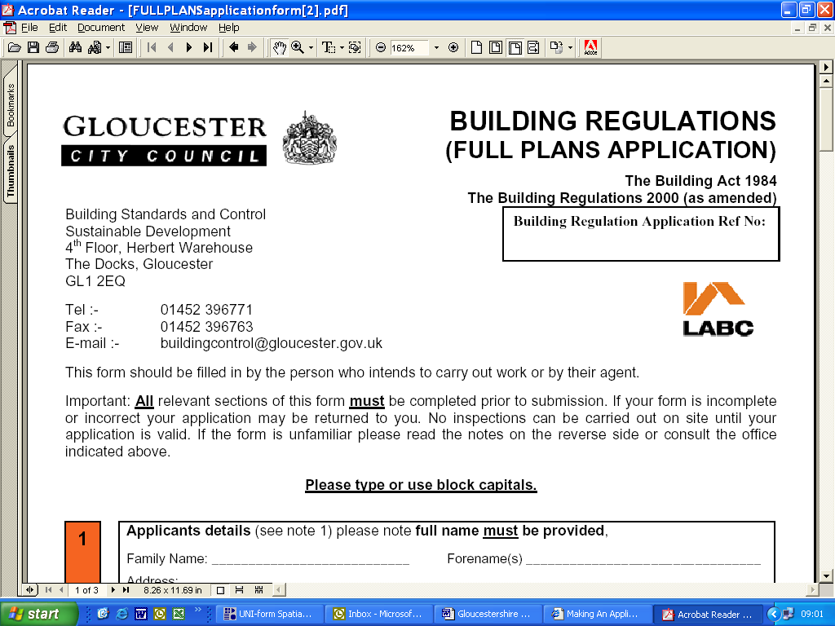 |  |  | Gloucester City Council  Building Standards & Control, 4th Floor, Herbert Warehouse, The Docks, Gloucester, GL1 2EQ
 |  |  | Tel: 01452 396771 | Fax: 01452 396763 |  | Email: buildingcontrol@gloucester.gov.uk
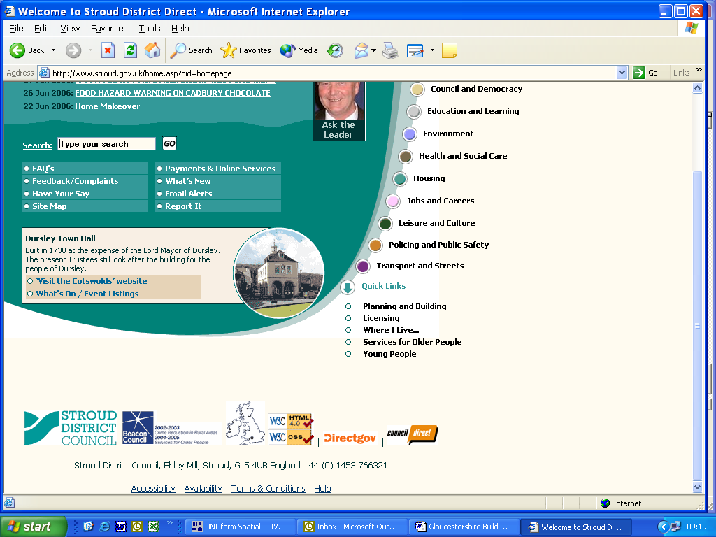 |  |  | Stroud District Council  Building Control Services, Ebley Mill, Westward Road, Stroud, Glos, GL5 4UB
 |  |  | Tel: 01453 754518 |  | Fax: 01453 754511 | Email: building.control@stroud.gov.uk

APPLICATION NOTES

You may choose to submit either the ‘Full Plans’ or ‘Building Notice’ option for new building work
however the ‘Building Notice’ option can not be used where:

- The building is a ‘designated use’ under the Fire Safety Regulatory Reform Order which includes offices, shops, factories and hotels and/or is a workplace subject to the Fire Precautions (Workplace) Regulations 1997 to enable consultation with the fire authority.

- The building work is over or near a public sewer.

- The proposed new dwelling/s front onto a private street.

Both methods have the same charge and both are inspected on site to ensure compliance with
the Building Regulations

The Regularisation option is to be used for work that has already been carried out, please refer to the separate application form and charge sheet for details.

Building Notice applications
- One copy of this form should be completed and submitted with the appropriate fee and a site plan to a scale of 1:1250 or 1:12500 to show drainage details and boundaries of site. Additional information may also be requested, e.g. engineer’s calculations.
General Information
Applicant: | The applicant is the person on whose behalf the work is being carried out, e.g. the building’s owner.
Agent: | The agent is the person or company dealing with the application. Please note that correspondence will be sent to the person/company named as agent.
Exemption: | Some works solely for the benefit of the disabled are exempt from payment. Please contact the Building Control office for details.
Validity: | If work has not commenced after three years from the date the application was submitted, the application will no longer be valid.
Commencement: | Commencement of work means the definition given in Regulation 46Aof the Building Regulation 2010 (as amended). Generally, this means when foundations and the lowest floor structure is complete or where there is no foundation work when 15% of the work is complete.
Completion: | Please arrange for a final inspection to be carried out in order that the Local Authority may issue a completion certificate. If electrical works have been carried out, we will require a copy of the electrical certificate before we can release our Building Regulation certificate. These certificates should be retained with your deeds as they will be required when your property is sold.

Cheltenham and Tewkesbury Building Control Service provides building regulation services to you. We will use your personal information to provide those services to you and may need to share your information with professional/official consultees (such as the Fire Service in commercial applications) to enable us to do this. For further information about how the council uses information it holds about you please go to our GDPR page.

Updated: May 2018

