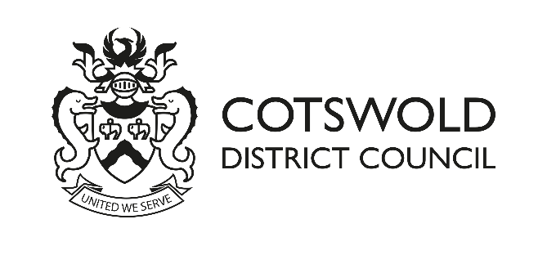

NORTH MEADOW AND CLATTINGER FARM SPECIAL AREA OF CONSERVATION
RECREATIONAL IMPACTS MITIGATION CONTRIBUTION
S.111 of LOCAL GOVERNMENT ACT 1972 AGREEMENT
GUIDANCE NOTES

Summary
This note provides guidance on completing a s.111 of the Local Government Act 1972 Agreement to ensure that the appropriate mitigation is secured to prevent new developments causing additional recreational disturbance to the biodiversity of the North Meadow and Clattinger Farm Special Area of Conservation (SAC).

Background

North Meadow and Clattinger Farm are internationally important for biodiversity and are designated as a Special Area of Conservation or Habitats site. Only the North Meadow element of the SAC is relevant to this guidance note. North Meadow supports important meadow species, for example the snake’s head fritillaries and is also very popular with visitors. However, the high number of visitors is impacting on the site and damaging the wildlife. It is crucial that steps are taken to protect the site and to reduce the recreational impacts.

Recreational Mitigation Strategy
Cotswold District Council is legally obliged under the Conservation of Habitats and Species Regulations 2017 (as amended) to consider whether any project or proposal, including planning applications would affect the biodiversity of the North Meadow SAC. We have worked with our partners, including other adjacent Local Authorities and Natural England to develop the North Meadow and Clattinger Farm SAC Recreation Mitigation Strategy (2023)
This includes –
- an analysis of where visitors to the site come from,
- the types of measures necessary to mitigate the impacts. The measures are divided into
  - on-site measures, e.g. rangers, signage
  - off-site measures – the provision of suitable alternative natural green spaces, (SANGS) and other infrastructure mitigation projects (IMPs)
- the costs of those measures.

The analysis of the visitor information shows that there are two main types of users,
- all-year round visitors who come mainly from quite close to the site and who use the site for dog-walking and similar. The majority of these users come from within 4.2km of the SAC
- seasonal visitors who come to see the flowering fritillaries. The majority of these users come from within 9.4km of the SAC

Given that there are two types of users who come from different distances from the SAC and cause different impacts on the SAC two Zones of Influence (‘’ZoI’’) have been set.
- Inner zone 0 – 4.2km from the SAC
- Outer zone 4.2 – 9.4km from the SAC

All planning applications (and prior approvals) for residential or holiday accommodation, within the 9.4km of the SAC, will be subject to Habitats Regulations consideration.
This also includes –
- Houses in Multiple Occupation (sui generis);
- Residential institutions within the C2 Use Class where the residents are not severely restricted by illness or mobility;
- Student accommodation;
- Sites for gypsy, travellers and travelling show people;
- Tourist accommodation, including self-catering, caravan and touring holiday accommodation.

The need to address Habitats Regulations issues for other types of development will be considered on a case by case basis.

Implications for Planning Applicants

If an application falls within the residential/holiday accommodation category and is within 9.4km of the SAC there are two main options for applicants -
- Prepare your own “shadow” Habitats Regulations Assessment detailing the likely recreational impacts caused by your development and the mitigation that will be put in place to address those impacts. This is likely to be a very time-consuming piece of work and will require the input of experienced ecologists and others. This information should be submitted with your application. This will be subject to consultation with Natural England.

- Agree to contribute financially to the recreation mitigation strategy prepared by the relevant Local Authorities and Natural England. The costs are –
  - Outer zone £323/unit (+ admin fee)
  - Inner zone £803/unit (+ admin fee)

If you wish to use the contribution option, you should

Complete the relevant s.111 Agreement form, agreeing to make the relevant payment on receipt of the appropriate invoice, prior to determination. The contribution will be refunded – minus the administration charge – if permission is not granted (for details see the s.111 template form). It is important to use the s.111 template form that relates to the zone within which your development is located.
  - Cost - £323 or £803 per unit + an administration fee £125 per agreement

Alternatively you can complete and submit a Unilateral Undertaking (template version available on our website), agreeing that payment will be made prior to commencement of the development. The administration charge will be higher for the Unilateral Undertaking option as there is additional administration required by the Council. In cases where a s.106 Agreement is needed for other reasons, the contribution could be included within that s.106 and administration costs will be calculated separately. For particularly complex s.106 agreements a site specific administration charge will be levied.
  - Cost - £323 or £803 per unit + an administration fee £510

The administration fee has been calculated per site or agreement, not per unit of accommodation. The Council reserves the right to periodically review and amend both the administration fee and mitigation contribution.

Completing the S.111 Agreement

Section 111 Agreements provide Councils with a general power, under the Local Government Act 1972 for a variety of actions, including being able to secure these recreational impacts mitigation contributions. Template draft s.111 Agreements are available on the Council’s web-site and can be downloaded or completed digitally.

Guidance Notes

Application reference number
The reference provided by the Council is in the format – AA/BBBBB/CCC
AA – the year the application is submitted
BBBBB- unique reference number
CCC – application type e.g. OUT – outline application.
If you have submitted the application online and have not yet received a Council application number you can add the reference number provided by the Planning Portal.

Address of property
This should match the site address on the planning application form

Description of development
This should match the description of development on the planning application form.

Name of applicant
This should be the applicant’s full name, including surname and first name. (Provision of full name is a requirement of our finance system.)
If the applicant is a company, the company business name should be provided along with a named contact at that business.

Correspondence address of applicant
This address will be used for correspondence relating to the s.111 agreement including for any invoices. It must be the correspondence address for the person(s) who will be legally responsible: a ‘care of’ (c/o) address cannot be accepted.
Number of new residential / holiday within relevant Zone of Influence (ZoI)
Ensure that you are clear within which ZoI your development is located – your Planning Case Officer should be able to provide this information and that you complete the correct s.111 agreement

Signing the Agreement
Please make sure you sign and date the Agreement and return to the Case Officer for your application. A digital signature is acceptable.

Once the S111 Agreement has been completed and received by the Council, you will be sent an invoice which can be paid online, via telephone or via BACS transfer. Further details regarding payment will be available on the invoice.

Once payment has cleared, you will be sent a copy of the S111 Agreement, signed by an Officer of the Council. This is a legal Agreement and should be kept in a safe place.

https://publications.naturalengland.org.uk/publication/6299293463871488
https://www.legislation.gov.uk/uksi/2017/1012/contents/made

